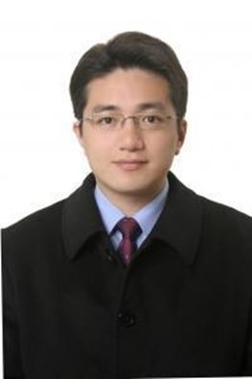
Resume URL:  https://jason660519.github.io/jason_resume/  Contact information  Email  a0405142777@gmail.com  Mobile  +61 405142777  Git hub Repo: https://github.com/jason660519 |  | Jason Yu  SKILLS  - Coding: C, C++, C#, Rust, Python, ABB Robotics RAPID  - ML & CV: Tensor flow, PyTorch , LLM Fine tuning skills, PyDICOM, YOLO  - AIGC: ComfyUI,  - AI Agents: LangChain, Ollama, RAGs  - UI/UX: Figma, Vue, React  - Back End: GCP, AWS, Azure, Docker, K8s, Terraform  - Robotics: OpenCV, ROS2 skills  - Database: MongoDB, MySQL, PostgreSQL  - CADs &3D Modeling: SolidWorks, Tekla, Autodesk Revit, AutoCAD, Pix4d, Drone Mapping,  - Finance: Stocks, Futures, Options Robotics Auto Trading  - Real Estate: CCIM  professional certificates  - GitHub Action Certification  - HashiCorp Certified: Terraform Associate  - GCP professional Architect Certificate No.88174  - Google Cloud Skills Boost Badge Awards: 28 GCP Courses and 51650 League points  - Stock & Option trading strategies (Python API for Broker Interactive)  - Data structure and algorithm (JavaScript)  - Property Stock and Business Agent certificate-Australia  - USA: CCIM Certified Commercial Investment Member No.14968  - USA: CRS: Certified Residential Specialist  - TED Talk Translator  - Taiwan Stock Exchange Salesperson Certificate  - Taiwan Futures Exchange Salesperson Certificate  - Taiwan Stock Exchange Senior Salesperson Certificate  - Success Resources Sales & Leadership Certification Program in Singapore  EDUCATION  National Taipei University of Technology  Civil Engineer Diploma Degree
WORK EXPERIENCES

Cullen Steel
Structural Designer + Machine & Robotics Operator
2022–2023
- Responsibilities: Responsible for designing and manufacturing 3D steel structural models using CAD and operating robot systems such as Tekla, Autodesk Revit, and ABB Robotics.
- Achievements: Effectively utilized robotics technology to improve manufacturing efficiency and ensure products meet design requirements and standards, achieving high-quality production.

Vertical Studio
Commercial Real Estate Consultant
2017–2021
- Responsibilities: Provided professional consultancy services for commercial real estate, including market analysis, investment evaluation, and property management.
- Achievements: Successfully assisted clients in real estate investments, finding high-return opportunities, and increased property value through effective management and market research.

Vision Realty & Sincere Real Estate
Marketing Specialist
2014–2017
- Responsibilities: Develop strategies, and scale for company products coach, mentor, and grow team members. Led the sales team in defining, developing, and positioning customer products, and launching marketing campaigns. Ensured alignment with the needs and preferences of target audiences.
- Achievements: Broke the company's new commission record, achieving TWD10 million in sales in a single month in 2014.

Real Estate Agency (Franchise Business Owner)
Commercial Real Estate Investor
2000–2014
- 2010 Top 3 Sales for the company.
- 2007 Top 1 Sales for the company.
- 2003 Top 2 Sales for the company.
- 2002 Rookie Award.
- 2001 Top 1 Sale for the company.
1999–2000 CMC Magnetics QC Engineer
1998–1999 Cold Spring Biotech Bio & Chemistry Specialist

